Notes on AWS API-01
Amazon API Gateway is a fully managed service from Amazon Web Services that lets you create, publish, secure, and monitor APIs at any scale.
In simple terms, it acts as a front door for your applications—handling incoming requests and routing them to backend services like AWS Lambda, databases, or servers.

🔹 How API Gateway Works
- A client (browser/mobile app) sends a request
- API Gateway receives it
- It processes things like authentication, throttling, validation
- It forwards the request to a backend (e.g., Lambda)
- It returns the response back to the client

🔹 Key Features
1️⃣ API Creation & Management
- Build REST APIs, HTTP APIs, and WebSocket APIs
- Define endpoints (e.g., /users, /orders)

2️⃣ Integration with Backend Services
- Works seamlessly with:
  - AWS Lambda (most common)
  - EC2 instances
  - Containers (ECS/EKS)
  - Other AWS services

3️⃣ Security & Access Control
- Supports:
  - IAM roles
  - API keys
  - OAuth / JWT
- Protects your APIs from unauthorized access

4️⃣ Traffic Management
- Throttling (limit requests per second)
- Rate limiting
- Caching for faster responses

5️⃣ Monitoring & Logging
- Integrated with Amazon CloudWatch
- Tracks:
  - API usage
  - Latency
  - Errors

6️⃣ Scalability
- Automatically handles thousands to millions of requests
- No server management required

🔹 Common Use Cases
✔ Backend for Web & Mobile Apps
- Build scalable APIs for apps
✔ Serverless Applications
- Combine API Gateway + Lambda for fully serverless architecture
✔ Microservices
- Acts as an API layer to route requests to different services
✔ Real-Time Applications
- WebSocket APIs for chat apps, live dashboards

🔹 Example Flow (Simple)
User → API Gateway → Lambda → Database → Response

🔹 Advantages
✅ Fully managed (no infrastructure)
✅ Secure and scalable
✅ Easy integration with AWS ecosystem
✅ Supports multiple API types

🔹 Limitations
⚠ Can add slight latency
⚠ Pricing can grow with high traffic
⚠ Configuration can be complex for beginners

🔹 Quick Analogy
Think of API Gateway like a receptionist at an office:
- It receives requests (visitors)
- Verifies identity
- Sends them to the right department (backend service)
- Returns the response
Created a new API gateway:
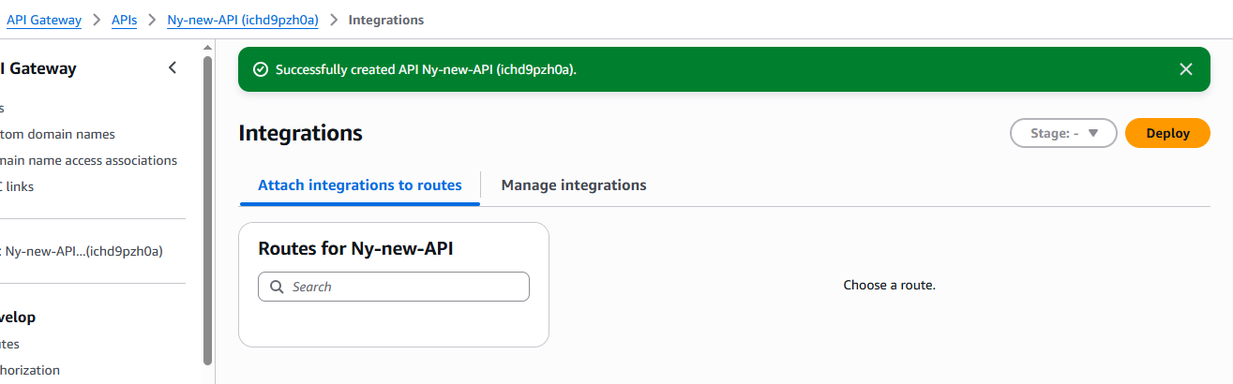
Created a new route for API gateway:
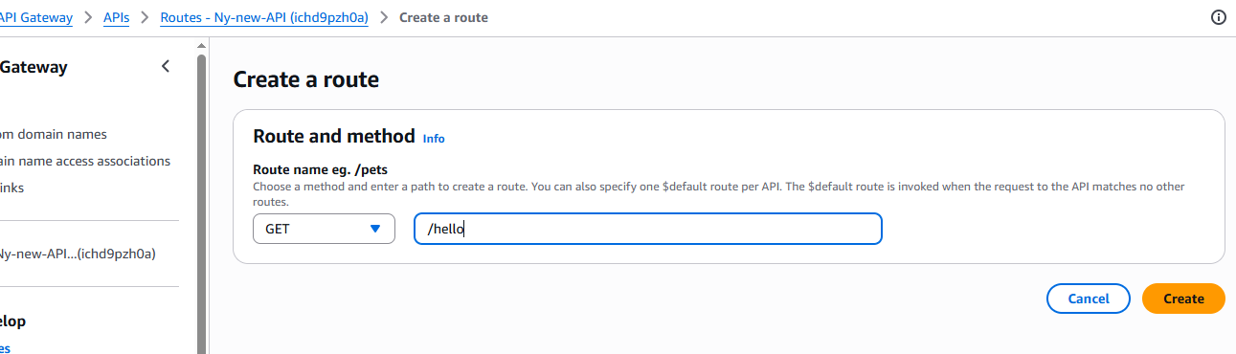
Created a new API with the below provided details:
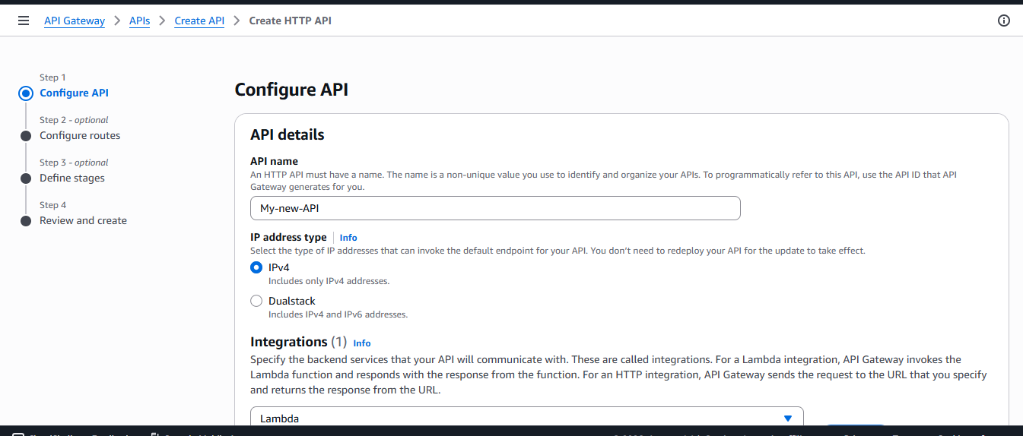
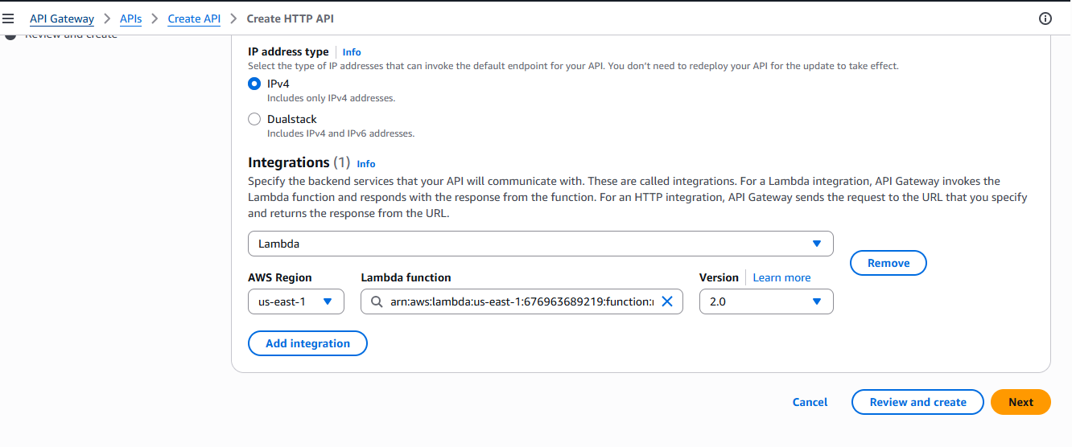
Then created a new route with the provided details as shown below:
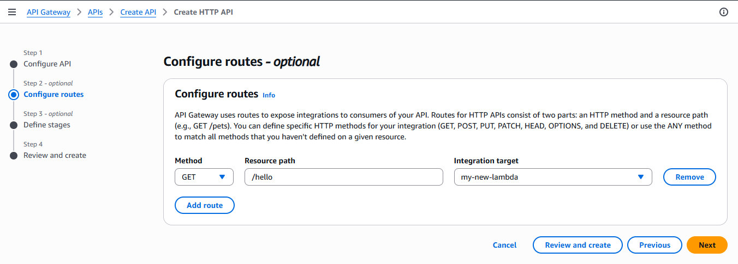 Copied the below path from the left side API section and then pasted in the browser with the /hello {resource path} and got the message on the browser from the lambda:
Default endpoint
Enabled
https://oc3mk5alj8.execute-api.us-east-1.amazonaws.com
